
PT1/IPCAK/1223/A 08-MAY-2023
PERIODIC TEST - I (2022-23)
Subject: Informatics Practices(c)
Grade: XII (Answer Key)
 | SECTION A |  | (9)
1. | Ravisha has stored the records of all students of her class in a MYSQL table. Suggest a suitable SQL clause that she should use to display the names of students in alphabetical order. |  | 1
 | - SORT BY
 | - ALIGN BY
 | - GROUP BY
 | - ORDER BY
2. | To remove the leading and trailing space from data values in a column of MySql Table, we use |  | 1
 | - Left
 | - Right()
 | - Trim()
 | - Ltrim()
3. | If the substring is not present in a string, the INSTR() returns:  - -1  - 1  - NULL  - 0 |  | 1
4. | Which of the following is not a valid aggregate function in MYSQL? |  | 1
 | - COUNT()
 | - SUM()
 | - MAX()
 | - LEN()
5. | Which function accepts a character string as an input and provides character string or numeric  values as an output? |  | 1
 | - Text
 | - Time
 | - date
 | - math
6. | Identify single-row functions of MySQL amongst the following.  - TRIM()  - MAX()  - ROUND()  - Both (a) and (c) |  | 1
7. | Predict the output of the following query:  SELECT MOD (9,0); |  | 1
 | - 0
 | - NULL
 | - NaN
 | - 9
8. | Complete the query select _______('2023-05-11')+1; so that it returns 6  - Date  - Month  - Year  - Dayofweek |  | 1
9. | _________________ is used to delete existing records in a table.  - REMOVE  - DELETE  - DROP  - CLEAR |  | 1
 | SECTION B |  | (12)
1. | State the purpose of the following functions:  - Mid()-to extract a part of a string  - mod ()-to return remainder |  | 2
2. |  |  | 2
  COUNT() | COUNT(*)
  It counts and returns records except null values from specified column | It counts and returns all values including null values
  It takes column name in the parenthesis | It takes * in the parenthesis
  It is very effective to count unique records from table | It is not effective to count unique records from table
  Ex.: select count(dpetno) from emp; | Ex. select count(*) from emp;
3. | Aryan, a database administrator, has grouped records of a table with the help of group by clause. He needs to further filter groups of records generated through group by clause.  Suggest suitable clause for it and properly explain its usage with the help of an example.  Ans having clause and give a suitable example |  | 2
4. | Create a table INVENTORY with the given structure:  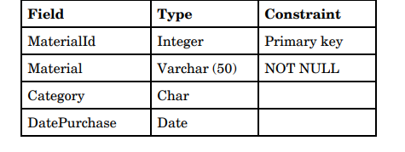 |  | 3
5 | i)  SUBSTR(“CLIMATE CHANGE”, 4,4)  —————————————-  MATE  (ii)  UCASE(RIGHT(“Pollution” , 3))  ———————————-  ION  (iii)  SELECT LENGTH (“HAPPY”)+3  ———————————  8 |  | 3
 | SECTION C |  | (14)
1 | Write SQL queries for the following:  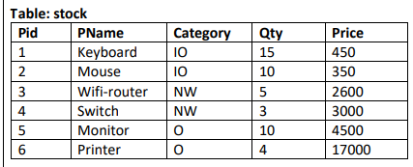  (a) To display the records in decreasing order of price.  (b) To display category and category wise total quantities of products.  (c) To display the category and its average price.  (d) To display category and category wise highest price of the products. |  | 4
2. | Consider the table STUDENT given below, write MySQL Commands for (i) to (v).  Table: Student  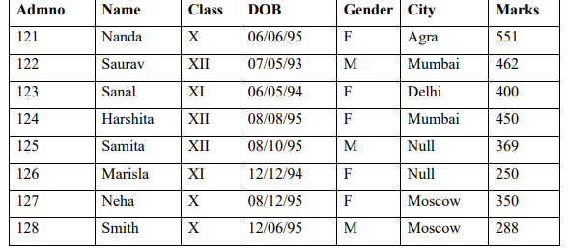  i i. To display name and marks. (Note: Marks should be shown as increased value by 10  i.e marks+10).  SELECT NAME,MARKS+10 FROM STUDENT;  ii. To display students records whose name starts with 'N' alphabet.  SELECT * FROM STUDENT WHERE NAME LIKE "N%";  iii. To display all the information of females whose city is NEITHER Delhi nor Mumbai.  SELECT * FROM STUDENT WHERE GENDER="F"AND NOT CITY  IN("DELHI","MUMBAI");  iv. To display the details of all the students whose date of birth is after Nishant’s Birth date  12/6/95.  SELCET * FROM STUDENT WHERE DOB>"1995-6-12";  v. To display admno and Gender of those students whose city is not known.  SELECT ADMNO, GENDER FROM STUDENT WHERE CITY IS NULL |  | 5
3. | Write the SQL queries which will perform the following operations  - select year(‘2023-05-15’);  - select lower(‘ABC@XYZ.COM’); or select lcase(‘ABC@XYZ.COM’);  - select ltrim(‘my country’);  - select date(now());  - select pow(10,6); |  | 5
***

